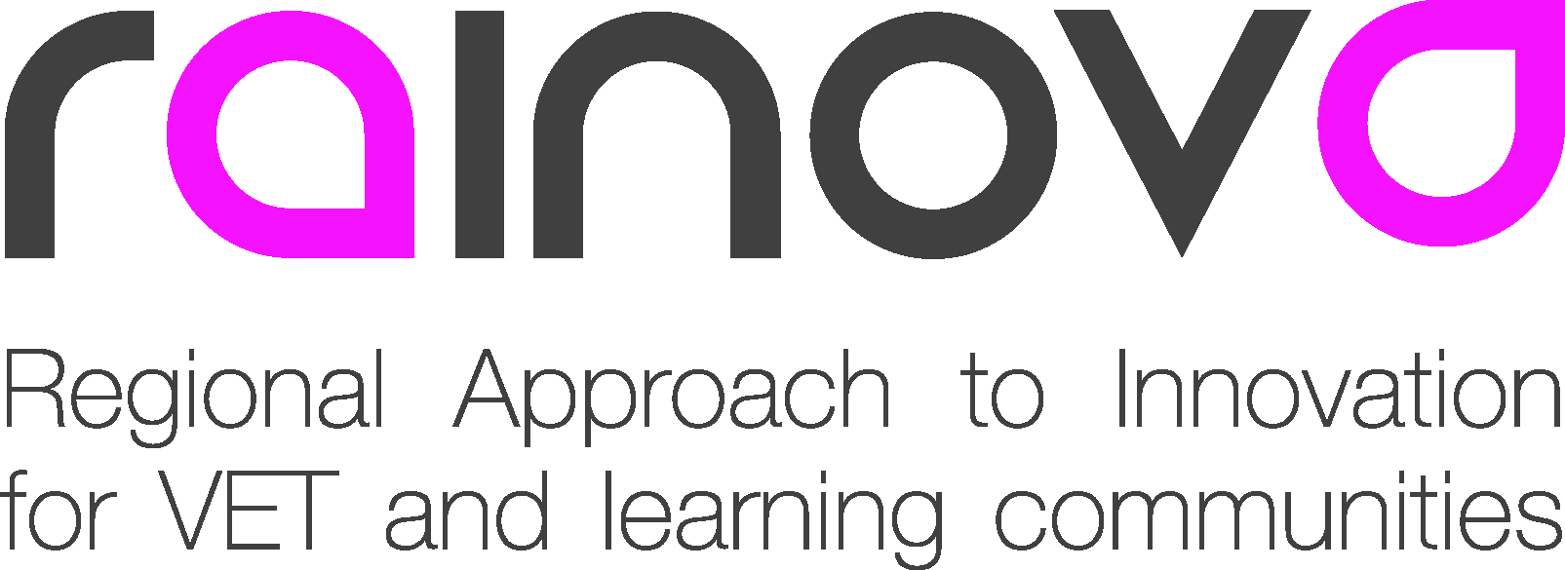 | 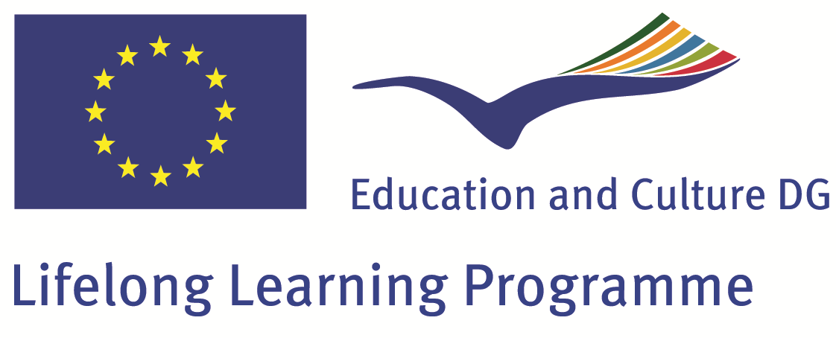

Project Number: 517752-LLP-1-2011-1-ES-LEONARDO-LNW

Project acronym: Rainova

Project title: Regional Approach to Innovation
for VET and Learning Communities

Work package: W09

Deliverable title: D17 Action Plans for the implementation of Regional Innovation Networks

Draft: version 0

Project co-funded by the European Commission within the Lifelong Learning Programme (2012-2014)
Dissemination Level
PU | Public
PP | Restricted to other programme participants (including the EC services)
RE | Restricted to a group specified by the Consortium (including the EC services)
CO | Confidential, only for members of the consortium (including EACEA and Commission Services and project reviewers) | X

Table of Contents

Summary 3

Introduction of the Work Package 09 4
1.1 Purpose and scope of the Plan 4
1.2 Action Plans 5
1.2.1. Methodology to know development levels 5
1.2.2. Methodology to apply Rainova IMM 5
- To Create RIS
- To improve existing RIS

2. Work package organization 19
2.1 Management structure
2.2 Consortium partners involved in the work package

3. Time schedule for the work package 20

Summary

Short summary of the purpose, scope and content of the Rainova project

The main aim of the RAINOVA project is to encourage the development of Regional Innovation Systems for the regions represented by the project partners. This aim will be achieved through the following objectives:

- To research the current situation in each region in terms of current innovation systems and strategies

- Identify agents within the region that act in the field of innovation (educational organizations / government departments / entities specialized in research and innovation / business organizations, etc.)
- Describe the role that each institution plays in the general innovation process
- Set out the existing relationships between the different identified agents
- Identify the different standards, programs and other resources existing in each region related to innovation management

- To design an Innovation Management Model that, as well as creating the flexibility required for each organizational and/or regional context, means that the challenge of innovation can be tackled in a more coordinated and intelligent way:

- Create “virtual” Innovation Observatories in each region which will gather relevant information on-line on the areas of interest
- Produce an Innovation Observatory Guide to help organizations navigate the information
- Evaluate the usability and use of the Innovation Observatories
- Develop the Innovation Management Model methodology using the results of the evaluation

- To draw up Action Plans for the implementation of the IMM in regional networks identifying the interventions needed to create or improve the regional innovation systems.

- To pilot the IMM in the 4 regions of Tuscany, Wales, Syddanmark and Basque Country (who are all members of EARLALL) focusing on an innovative sector with emerging technologies.

- To create the Regional Networks in each partner country:

- support and monitor the development progress of the networks
- monitoring the implementation of the action plans
- adapting and improving the IMM after the pilot
- initiating co-operation between the regional networks
- facilitate future studies of the innovation networks
- providing guidance and inspiration

6) To facilitate the creation of the International Innovation Network

Introduction of the work package 09

This document is for designing Action Plans to promote the implementation of Regional Innovation Networks and, at the same time, to serve as a first test or cycle for some of the elements of the Innovation Management Model designed in Work Package 07.

So, for the designing of these Action Plans we have to consider, at first, the previous findings of the Rainova Research Report. Then, we have to take into account the elements and methodologies presented in Work Package 08, in the Innovation Management Model.

This document should be useful as well for designing methodologies for identifying different levels of implementation in innovation management.

To facilitate this task, we make a difference between regions which are starting their journey towards innovation and regions which have already certain experience in innovation matters. In the first group of regions, our purpose will be to create a regional innovation system. With the second group of regions we should try to find ways to improve the work they are doing around innovation.

1. Purpose and Scope of the Action Plans

- To create RIS in regions where innovation lacks support, tools, models.
- To improve RIS in areas, systems and networks with experience on the innovation concept.
- To identify how to implement Rainova IMM in RIS and how to work on it with its members (leaders, actors, companies)
- To develop a methodology for knowing levels of development in the regions.
- To include sectorial networks and wider networks in the initiative.

2. Action Plans

2.1 Methodology to know development levels

Regions: To know the degree of innovation development in the region the following methodology will be applied:

For the purpose the Innovation Union Scoreboard (IUS) will be used. The annual Innovation Union Scoreboard provides a comparative assessment of the research and innovation performance of the EU27 Member States and the relative strengths and weaknesses of their research and innovation systems. It helps Member States assess areas in which they need to concentrate their efforts in order to boost their innovation performance.

The newest report can be downloaded from the web page:
http://ec.europa.eu/enterprise/policies/innovation/policy/innovation-scoreboard/index_en.htm

The Innovation Union Scoreboard (IUS) is an instrument of the European Commission, developed under the Lisbon Strategy and revised after the adoption of the Europe2020 Strategy to provide a comparative assessment of the innovation performance of EU Member States. It follows the European Innovation Scoreboard established in 2001. Together with the Regional Innovation Scoreboard and the pilot European Public Sector Innovation Scoreboard (under development), it forms a comprehensive benchmarking and monitoring system of research and innovation trends and activities in Europe. The most recent IUS 2013 has shown that the European Union has become more innovative but the innovation gap between countries is widening.

The annual Innovation Union Scoreboard identifies four groups of innovation level from highest down to lowest one):
- Innovation leaders: all show a performance well above that of the EU average,
- Innovation followers: all show a performance close to that of the EU average,
- Moderate innovators: the performance of those countries/regions is below that of the EU average,
- Modest innovators: the performance of those countries/regions is well below that of the EU average.

Innovation leaders and innovation followers are countries/regions, which have already certain experience in innovation matters and where the Action Plan serves to improve Regional Innovation Networks (RINs) and Innovation Management Model (IMM).

Moderate innovators and especially modest innovators are countries/regions that are starting their journey towards innovation and where the Action Plan will serve to establish RINs and implement IMM.

Every two years the Innovation Union Scoreboard is accompanied by a Regional Innovation Scoreboard (RIS). The Regional Innovation Scoreboard provides a comparative assessment of how European regions perform with regard to innovation. The report covers 190 regions across the European Union, Croatia, Norway and Switzerland. The Regional Innovation Scoreboard is based on the methodology of the Innovation Union Scoreboard and is accompanied by the Regional Innovation Scoreboard 2012 Methodology report.
The most recent RIS 2012 has shown that that there is considerable diversity in regional innovation performance not only across Europe but also within the Member States. Most of the European countries have regions at different levels of innovation performance. However, the most innovative regions in the EU are typically in the most innovative countries.

Organizations / Companies: To know the degree of innovation development in the organizations and companies of the region the following steps can be taken:

- Phase 1: requires consensus among the management team on the desired outcomes and clarity on how data and evidence is going to be gathered, assessed and presented.
- Phase 2: is performing the actual assessment, using survey based on Rainova IMM proposals and its elements to know to what extents these organizations are managing innovation.
- Phase 3: is the management team coming together to decide on what to do with the outcomes.

As assessment (diagnostic) tool for current situation analysis the Innovation Questionnaire is suggested. The description of the innovation assessment technique (a diagnostic tool that evaluates the organizational innovation management level) is to be downloaded currently from RAINOVA project internal web page:
Rainova File Library -> Work packages -> WP08 IMM -> Bulding_Rainova_IMM -> 03_Diagnostic_Tool -> Drafts -> 03_Starting_Point_v0.doc

2.2 Methodology to apply Rainova IMM (Framework of the IMM / Guidelines for applying the Model))

- To create RIS

To create a RIS in regions needing support to promote innovation, we must identify main institutions, organizations (by typology) and stakeholders to play a major role in implementing innovation in the regions. (To the Observatory) Then we must decide with whom to start working on Rainova IMM. And once we have selected them we can launch several actions:

  - With Institutions (macro level): Regional Government Units, Town Halls
    - To show results of the Rainova Research Report
    - To show IMM proposals and contents
    - To show our intentions about the Observatory and the Network
    - To assess about how to support the IMM, the Observatory and the Network: policies, programmes, strategies to promote good leadership, entrepreneurial mindset, right competences, collaboration. Suggested could be the following actions:

      - Promoting a change of mentality, management (including incentives), and culture in public institutions, including research institutes, so that they are more willing to participate in innovation networks.
      - Supporting business environment institutions: this action encompasses supporting regional development of the environment of enterprises and is aimed at eliminating formal and non-formal barriers and increasing their competitiveness. The subject of this action is the creation of a network of connections between the supporting units and the entrepreneurs, as well as dissemination of knowledge on the conditions and specificity of the region’s economy among entrepreneurs by supporting regional bridge institutions connecting the environment with the economy.
      - Economic cooperation in the region: this action encompasses supporting the cooperation of enterprises in the scope of creating cooperative, distribution, capital groups, enterprise and self-government entity associations, e.g. by creating network structures. The subject of this action is support for implementation of common endeavors of enterprises with scientific-research units and institutions responsible for regional development, improvement of the general investment climate, improvement and simplification of the administrative proves associated with performing economic activities, enhancing the system of entrepreneur incentives and creating incentives to undertake common investment endeavors (using the effect of synergy).
      - Building the capacity of actors willing to be network facilitators through courses and mentoring. These actors may be dedicated organizations that foster the exchange of ideas and shape the public debate on particular topics.
      - Establish a single umbrella organization. A single umbrella organisation can be established, which has the following functions: facility to raise awareness of innovation, collecting and disseminating information about innovation, services for training and providing consultation on innovation, services supporting innovation for partnerships and corporations, bringing together all the stakeholders, setting up a sustainable structure, developing capabilities and a monitoring & evaluation system to assess the different methods used to promote innovation networks and network facilitators. It is necessary to organise introductory activities for these innovation systems through: panel and symposium activities, meetings, clustering facilities, media campaign.
      - Financing RIN facilitators - innovation brokers, business incubators, NGOs, researchers, extension agents, and groups of entrepreneurs - that assemble potential partners. Their remuneration should be linked to measures of the consolidation of the network. The milestones should not be imposed by the financing institution but negotiated between potential partners, funders, and the innovation broker. When the milestones are defined by the funders alone, innovation brokers tend to respond to their interests instead of those of potential network partners. The facilitators should be trained in the different methodologies that have been developed to foster the emergence of partnerships.
      - Giving small, short-term grants to potential facilitators of networks to facilitate interactions with potential partners, such as organizing meetings or establishing electronic platforms for communication.
      - Broadening the mandate of research and extension institutions to include promoting innovation networks. Appropriate incentives should be introduced and resources made available.

    - To gather feedback on proposals

  - With Organizations / Companies / Persons (micro level):
    - To show results of the Rainova Research Report
    - To show IMM proposals and contents
    - To show our intentions about the Observatory and the Network
    - To assess about ways and steps to apply the IMM: To present best practices, management tools, learning activities, possibilities of collaboration, access to grants, etc.:

- Presentation - Training on the Model (Shared understanding / Whole picture / Systematics part / Contextual part / Linkages)
- Situation Analysis (Diagnostic Tool)
- Selection of a “closed” project
- Development of the project (Innovation Tool Box)
- Assessment of the experience (Learning Innovation Assessment Tool)

    - To gather feedback on proposals

  - Steps for building Regional Innovation Network (RIN):
    - Identifying themes and activities important for region (best idea is to choose from list of regional Smart Specializations), around which RIN will be created.
    - Identifying facilitator of the RIN (committed and innovative facilitators are vital to the emergence of innovation networks, because by definition only they can induce other partners to invest time and resources in the network, and they also seek partners to contribute the resources needed by the network).
    - Identify sources of funding/founders for operation of facilitator and creation of network.
    - A facilitator must seek partners willing to contribute to the common effort, identify which capabilities the network needs, and look for new partners that can contribute those capabilities until at least one is found. In searching for partners to initiate an innovation network, it is important to focus both on individuals and institutions. Support from top management is of little help if the people who must participate in field activities are not motivated.
    - Contacting and involving players from local communities (there shall be strong interest among partners to deal with the defined theme, especially persons, because Innovation networks are made up of individuals, even if they represent an organization. Their contribution to the collective effort depends on the personal benefits they gain from participation, the incentives offered by their organizations, and their organizations’ cultures).
    - Identify common goals of the RIN participants, for example involving entrepreneurs and associations/networks in the processes of economic development plans and programs at universities.
    - Identify scheduled action plan along the goals.
    - Building trust between members of the network as a prerequisite of engaging them in collaborative development of innovation.
    - Defining and managing joined initiatives aiming to increase the local and global competitiveness of stakeholders.
    - Jointly developing, delivering and promoting concrete products or valued-added services to be used by members of the community (given their voluntary nature, innovation networks survive when they can implement collective action); create a common, comprehensive services, but primarily to ensure the identification of the existing market niches, leading to a wider range of completely new elements.
    - Sign formal agreement? To support the emergence and consolidation of innovation networks, recognize their informal nature. Avoid imposing formal organizational arrangements. Innovation networks should not be pushed to adopt a formal structure. Given the uncertain nature of innovation, formal contracts and intellectual property rights are seldom important for the development of innovations that are a little more complex than incremental improvements, but any formalization of cooperation can significantly strengthen the negotiating position of the institution in the context of the ability to participate in large international projects, pro-innovation.
    - Ensure effective communication among network members (use of modern communication tools and means, like social media used on mobile applications)
    - Design and implement the Innovation Web platform to support project partners actively communicating with the local community (utilizing the mother language) while being linked to the global community (utilizing the international business language, i.e. English); The platform serves as the means for exchanging good practices, providing information about events and activities, and presenting concrete collaboration offers.
    - Organisation of series of workshops in relation to innovation and networking capabilities, as well as cluster/networking policies and practices – dissemination of the benefits of cooperation in the innovation environment, to inform about innovation, network and clustering activities that increase their institution’s potentiality to collaborate, to promote entrepreneurship and innovativeness based on the open innovation concept and to disseminate identified good practices.
    - Development & dissemination of Newsletters
  - For sectorial networks:
    - Identifying the sector of activity where RIN will be created
It seems impossible creating a RIN for each sector in a region. In order to select correctly the sectors we would like to push a RIN, we should identify the different sectors existing already in our area, having presence there, and choose one or some of them to carry out the creation of the RIN. To make a right selection different criteria should be analysed:

      - Knowledge of the sector in the region (the know-how already existing)
We should develop the innovation network in a sector where the number of companies is high enough, where the knowledge is expert-level and where the culture of collaboration could potentially be high.
      - Smart diversifying activity
In order to position a region and an activity sector, as the most innovative one in a wider area, we should select or identify emerging activities that are closed to our core know-hows. In case our main production activities are mature activities, we should improve smart diversifying processes. We cannot expect to diversify in a lot of fields and to make it well in all of them.
      - Culture of partnership
Most of participants in these RIN are rivals, in case we select a specific sector of activity. To create a RIN successfully, participants should maintain the correct balance between competition and collaboration. If they get it, they will improve the competitiveness of each company through cooperation. So, the relationship created between companies, will develop synergies and if we take advantage of them, we will succeed in projects that would be impossible to undertake individually
    - Contribution of sectorial networks as Clusters to the competitiveness of companies
Different sectorial networks contribute to the competitive advantage of the company as well as the improvement of the competitiveness in the region. These improvements are based on, i.e.:

      - Increasing productivity, because of the specialization in certain markets or products
      - Promoting innovation, higher ability to detect new needs
      - Creating new companies, because of the reduction of risk and entry barriers and the existence of potential clients for these new companies

    - Identify potential supply chain companies
Related to the value chain to which one activity sector belongs we should have in consideration the next considerations:

      - Market
The same sector could belong to different value chains, depending on the market. Different last markets for the same activity sector can create different complementarities between sectors or companies and, therefore, this sector of activity could belong to different parts of different value chains.
      - Cluster
In clusters based on the value chain, the proximity of suppliers and buyers permits lower costs and a better offer. So, to identify potential companies for the value chain, proximity would be important, in addition to the complementarity that they could have.

Definition of Institutions/Companies/Stakeholders and Actions to be taken

Name of Partner | REK |  | Name of Region |  | Dalarna
List of institutions |  | Selected institutions |  | Selected topics |  | List of actions
Dalarna University
Region Dalarna
Borlange Science Park
DalaWux

List of companies |  | Selected company |  | Selected topics |  | List of actions
Tension
Right Education
Yrkesakademin

List of stakeholders |  | Selected persons |  | Selected topics |  | List of actions
Triple Steelix
ITS Dalarna
High Voltage Valley
Destination Dalarna
Dala Sports Academy
ByggDialog Dalarna
Boom Town
Researcher network
Svenskt Näringsliv
Företagarna
Handelskammaren
Näringslivet Falun-Borlänge

b. To improve existing RIS

As we have proposed previously we have to identify institutions, organizations and stakeholders in the region, and select those we are going to work with. The purpose in this case is to pay attention to the weaknesses detected in the research report and to suggest possibilities for improving the system on the type of organization and on the detected weaknesses, the actions can differ from each other. We suggest below some of the actions than can be undertaken by partners

  - With Institutions (macro level)
- To show findings of the Rainova Research Report and IMM proposals and contents, mentioning as well our intentions about the Observatory and the Network.
- To develop actions to support existing Regional Innovation Networks (RINs), especially investment:

- Resources to consolidate innovation networks, including the implementation of collective action (hire facilitators, build human resources with formal and informal training, and support travel, meetings, communications and communications products, and experimentation).
- Providing resources to strengthen innovation capabilities in private firms and civil society organizations/non public actors. For example, use consulting services, innovation brokers, innovation incubators, extension activities, technological interchanges, and seminars and workshops on the dynamics of innovation networks.
- Creating venture funds to finance the development of innovations, similar to those used in the high-tech industries.
- Fostering the transformation of public research and extension institutions so that they can better integrate into innovation networks.
- Building the understanding of the main actors, especially senior civil servants, of the dynamics of innovation and the nature of innovation networks.
- Support action-research projects and decentralized experimentation with centralized learning to identify new instruments to foster innovation networks and diffuse best practices.

- To develop actions and guidance about one specific element of the IMM which is considered of interest by the organization:

- Organization of series of workshops in relation to innovation and networking capabilities

- To gather feedback on proposals

- With Organizations / Companies / Persons (micro level)
- To show findings of the Rainova Research Report and IMM proposals and contents, mentioning as well our intentions about the Observatory and the Network.
- To develop actions and guidance about one specific element of the IMM which is considered of interest by the organization:

  - Designing of strategies for innovation
  - Tools for managing projects
  - Selection and empowerment of people
  - To work based on indicators.

- To gather feedback on proposals

- Supporting existing Regional Innovation Networks (RINs):
  - strengthen their ability to assess their strengths and weaknesses and gain access to needed resources
  - build the capacity of network leaders to steer nonhierarchical organizations
  - implement strategies to gain access to needed resources
  - develop capabilities to explore new instruments to develop and foster innovations
  - facilitate the implementation of joint activities
  - For wider networks:
- once the network has emerged, it is essential for it to establish effective links with other networks that can provide information, share experiences, and provide access to critical assets the network lacks. The links are often not provided by the facilitator but by other well-connected partners in so called “central nodes,” in the terminology of Social Network Analysis. The start of the work with creating wider networks is to analyse relationships and formal/informal networks between organisations and individuals within these organisations. Social network analysis/SNA views social relationships in terms of network theory, consisting of nodes (representing individual actors within the network) and ties (which represent relationships between the individuals. These networks are often depicted in a social network diagram, where nodes are represented as points and ties are represented as lines. One method in understanding each RIN:s connection to other networks is to create similar network diagrams between each RIN (and its members) and other networks. The wider network can consist of specific sectors or clusters, of non-profit organization/networks (like REK in Sweden) or other RIS on a national or international level. The wider network can consist of organization with a high level of innovation (like other existing RIS) or organizations/groups that are under development (and needs support and inspiration to develop to an RIS). Each RIS should examine the formal an informal networks between organisations and individuals, and create one or several Social Network Analyse and visualize them in a Social Network Diagram. See illustration below of a Social Network Diagram.

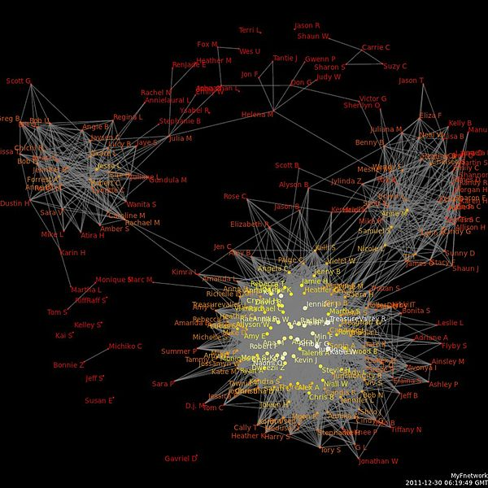

- To be able to create or develop wider network, each Partners will organize workshops on “Innovation & networking capabilities” aimed to build competences and match needs and services. These workshops will be the key phase in expanding the network for each RIS, and to share experiences between the RIS, other networks and organisations. One challenge is to get competing organizations and clusters to collaborate, and to create an awareness of the benefits for the region or for the country. Another challenge is to get managers and business developers from SME:s to contribute with their time, and to create a value for participating in the workshops for each company.
- One method in creating a common vision or goal for the wider networks could be to get each sub-network to organize a contest for “Best Open Innovation Idea/Practice”. I would also be an effective way of getting people to share their experiences with other networks. Each sub-network could then be a part of a regional/national contest and to get to meet the best of the best. By sharing knowledge across organizations and networks, there will be a better understanding of common challenges and possibilities. And by reusing knowledge from other networks and sectors new ideas and innovations can emerge that will benefit the whole community or region.
- When the wider networks have been researched according to SNA, and knowledge sharing has started to take place, it can also be useful to do study visits and look at specific projects, networks or cluster of organisations . It can be projects or networks outside the specific region and even outside the specific country. The RIS could arrange different study visits every year, as a method in creating a value of being part of the RIS or the wider network. You could also create joint open innovation workshops with other RIS in other regions or countries as a part of the sharing across the borders.

Definition of actions to improve regional weaknesses detected in the Research Report

Aegean Region, Izmir (Turkey)

WEAKNESSES: Aegean Region, Izmir | Proposed actions
Inadequate communication and information concerning innovation management models.

Basque Country (Spain)

WEAKNESSES: Basque Country | Proposed actions
Confusing methods of governing the system.
Small company size.
Low percentage of GDP invested in university R&D&i spending.
Scientific system lacks dynamism and connectivity.
Current economic crisis.

Dalarna region (Sweden)

WEAKNESSES: Dalarna | Proposed actions
Lack of understanding of the role of VET as a strategic tool to enhance work opportunities.
Lack of research on SME and regional development.
Lack of time for development activities.
Lack of leadership and competencies
Traditions and culture are obstacles to innovation.
Poor supply/demand matches.

Lower Silesia (Poland)

WEAKNESSES: Lower Silesia | Proposed actions
Low investment in research and development (R&D)  Limited willingness of SMEs to make changes and take risks.  Lack of openness to new technologies.  Lack of effective creative collaboration within enterprise supply chains.  Lack of long-term planning for SME development.  Inadequate human resource capacity.  Limited cooperation between business and technical colleges and universities to adapt educational programmes to market needs.  High unemployment caused by economic recession.  Lack of networking and cooperation between enterprises.  Low usage of information and telecommunication technologies in services. | Active participation of R&D representatives in regional consultations on Regional Operation Programme  Starting from workshops and visits explaining simple and low-cost changes improving processes and lowering costs (i.e. Lean Management)  Workshops for SMEs made by R&D institutions  Activities aiming including the companies in clustering activities by cluster animators and coordinators  Use expertise of existing institutions – for example results of projects for SMEs that produced management organisational tools for SMEs (www.lean.org.pl)  Starting collaboration with vocational training institutions  Bottom-up initiative done within clusters  ???  Activities aiming including the companies in clustering activities by cluster animators and coordinators  ???

Quebec (Canada)

STRENGTHS: Quebec | Proposed actions
Several actors are involved in the innovation process with little (or no) coordinated actions at different levels.
Low level of correspondence between educational institutions and market needs.
Low competition in some economic sectors.
Inadequate innovation culture.
Low rates of regional transfer of innovation.
Uneven distribution of new knowledge among regions.
Policies driven more by research and invention than innovation.

Sønderjylland region (Denmark)

WEAKNESSES: Sønderjylland region | Proposed actions
Weak connections between companies and education providers.
Shortage of highly qualified staff.
Lack of collaboration between education providers.
Lack of collaboration between universities and companies.
Shortage of venture capital (since financial crisis in 2008).
Loss of jobs in bigger companies (due to outsourcing).
Taxes too high to attract foreign employees and researchers.

South Muntenia Region (Romania)

WEAKNESSES: South Muntenia Region | Proposed actions
Difficulties in employing technical personnel due to government policies, laws and procedures.
Lack of private sector grants for research activity.
Poor participation by researchers in joint research programmes with other researchers from similar institutions.
The present system of regulations regarding researcher promotion is not very encouraging.
Slow adaptation to global requirements and changing research priorities, visions and directions.
Poor strategies for stimulating creativity.
No real connection to the labour market.
The volume of everyday work is a barrier to creativity.
Poor interaction among the districts of South Muntenia.

Tuscany region (Italy)

WEAKNESSES: Tuscany | Proposed actions
The connection between firms and the education sector appears to be weak.
The regional strategy should be better defined and implemented.
Research should be more business-oriented and market-driven.
Access to credit is difficult, especially for small firms.
Fiscal support for innovating firms would be widely welcomed.

Wales (United Kingdom)

WEAKNESSES: Wales | Proposed actions
Low investment in R&D by Welsh business and academia.
Little evidence of a culture of innovation in Wales.
Little evidence of an investment culture and an over-dependence on grants.
Lack of high-level skills and innovation management skills in many areas.
Weak external perception of Wales as a base for knowledge-based companies, resulting in an international image as a leisure destination.
Lack of international trade.

Västra Götaland (Sweden)

WEAKNESSES: Västra Götaland | Proposed actions
Lack of innovative thinking.
Lack of time for innovation.
Lack of formal strategy for innovation
Lack of will to change.
Lack of finance for innovation.
Difficulty keeping up with goals that change all the time.
Old/set traditions.
Old/set routines and company cultures.
Many students taught in traditional ways must learn how to adapt to changes in the market.
Difficulties understanding the value of collaboration.

Definition of Institutions/Companies/Stakeholders and Actions to be taken

Name of Partner | Mazhar Zorlu Technical and Industrial Vocational high School |  | Name of Region |  | Izmir
List of institutions |  | Selected institutions |  | Selected topics |  | List of actions
- Izmir Development Agency (İZKA)  - Gediz University  - Katip Celebi Univesity  - Dokuz Eylül Üniversity  - Yaşar Üniversity  - Agean University Science-Technology Application and Research Center (EBILTEM)  - Izmir Technology Development Region (İZTEKGEB)  - Izmir Atatürk Organized Industrial Zone (IAOIZ)  - Izmir Governship |  | - Izmir Development Agency (İZKA)  - Gediz University  - Katip Celebi Univesity  - Dokuz Eylül Üniversity  - Yaşar Üniversity  - Izmir Atatürk Organized Industrial Zone (IAOIZ)  - Izmir Governship |  | - To describe Innovation  - European Innovation Scoreboard  - To show results of the Rainova Research Report for Izmir  - To show IMM proposals and contents  - To assess about how to support the IMM |  | - Sending our draft IMM proposals  - A Panel will be organized (on 14 April 2014. The subject is “innovation in vocational training focused on industrial automation technologies”  - Gathering feedback on proposals
List of companies |  | Selected company |  | Selected topics |  | List of actions
- Karaca Mechatronic Systems  - Arcan Machinery  - Izmir Hand Tools Industry (IZELTAS)  - Inci Wheel Industry (JANTAŞ)  - TİRSAN (Tirsan Kardan Co) |  | - Karaca Mechatronic Systems  - Izmir Hand Tools Industry (IZELTAS)  - Inci Wheel Industry (JANTAŞ)  - TİRSAN (Tirsan Kardan Co) |  | - To describe Innovation  - To show results of the Rainova Research Report for Izmir  - To assess about ways and steps to apply the IMM: To present best practices, management tools, learning activities, possibilities of collaboration |  | - Sending our draft IMM proposals  - A Panel will be organized (on 14 April 2014. The subject is “innovation in vocational training focused on industrial automation technologies”  - Gathering feedback

3. Work package organization

3.1 Management structure

The WP Leader is partner P7 DPIN in Poland. They will work together with the Quality Management Team/QMT. The Actions Plans will be approved by the QMT.

The WP leader will be expected to manage the working documents on the extranet, inviting comments and contributions so that the outcomes reflect all member views. Forums will be the main communication tool between meetings as this ensures all partners are receiving the same information.

3.2 Consortium partners involved in the work package

Partner P7 DPIN To develop the framework for the Action Plans

Partner P5 Mazhar Zorlu To co-lead the WP. Identify results from the research to use as a basis

Partner P1 Ikaslan Methodology for Implementing the IMM

Partner P2 EUK SYD Translate into Danish

Partner P4 Adastra Edit and Design of the Action Plans

Partner P8 CSCS Translate into Italian

Partner P9 Colegau Cymru Translate into Welsh

Partner P10 Tolosaldea Develop the section for the sector networks

Partner P11 REK Develop the section for wider networks

Partner P12 Pitesti University Translate into Romanian

Time schedule for work package 09

Presentation of the time schedule:

- First Draft of Action Plans (to be presented in Sonderborg on 24 Feb 2014)
- Second Draft of the Action Plans (to be established in March 2014)
- Final Document of the Action Plans (to be established in May 2014)

The Action Plans are expected to be designed by the end of month 26 (February 2014)
The final document will be delivered by the end of month 27 (March 2014) to be edited and designed.

TIME SCHEDULE WORK PACKAGE 09
- 2014 -
Nº | PARTNERS | January | Feb. | March | April | May | June | July | August | Sept. | October | Nov. | Dec.
1 | Partner 1 | Method to implement IMM | Method to implement IMM
2 | Partner 2 |  |  |  |  | Trans-late into Danish
3 | Partner 4 | Revise and comment first draft | Revise and comment first draft | Revise and comment second draft | Revise and comment final document | Revise and comment final docu-ment
4 | Partner 5 | Revise and comment first draft | Revise and comment first draft | Revise and comment second draft | Revise and comment final document | Revise and comment final docu-ment
5 | Partner 7 | First Draft | First Draft | Second Draft | Final docu-ment | Final docu-ment
6 | Partner 8 |  |  |  |  | Trans-late into Italian
7 | Partner 9 |  |  |  |  | Trans-late into Welsh
8 | Partner 10 | Develop section for sector networks | Develop section for sector net-works
9 | Partner 11 | Develop section for wider networks | Develop section for wider net-works
10 | Partner 12 |  |  |  |  | Trans-late into Romanian

